

**Green University of Bangladesh**

**Department of Computer Science and Engineering (CSE)**

**Faculty of Sciences and Engineering**

**Semester: (Spring, Year:2022), B.Sc. in CSE (Day/Eve)**

**LAB PROJECT PROPOSAL**

**Course Title: Computer Networking Lab**

**Course Code: 321D Section:193 DB**

**Student Details**

|  |  |  |
| --- | --- | --- |
|  | **Name** | **Id** |
| **1** | **Md Ariful Hasan** | **193002037** |
| **2** | **Md Sah Imran** | **1930002067** |

**Submission Date : 28-04-2022**

**Course Teacher’s Name : Mohammad Ehsan Shahmi Chowdhury**

**Contents**

|  |  |
| --- | --- |
| **Serial No.** | **Title** |
|  | Title of the project proposal |
|  | Problem domain & motivations |
|  | Objectives |
|  | Tools and Techniques |
|  | Project Design |
|  | IP address plan |
|  | Implementation Details |
|  | Limitations |
|  | Conclusion |

1. **Title of the project proposal**

Office building network design

1. **Problem domain & motivations**

This Office Network Scenario is about designing a topology of a network that is a LAN (Local Area Network) for an Enterprise in which various computers of different departments are set up so that they can:

* interact and communicate with each other by interchanging data. To design a networking scenario for an Enterprise which
* connect various departments to each other’s,
* it puts forward communication among different departments.
* CNS is used to design a systematic and well-planned topology,
* satisfying all the necessities of the college (i.e. client). CNS come up with a network with good performance.

1. **Objectives**

The main objective of the proposed network is

* to update the existing network and also
* enhance its capabilities and increase the flexibility of the network which will eventually provide good security.

1. **Tools and Techniques**

* DNS,
* SMTP,
* FTP,
* IOT (fire detector, Motion Detector)

1. **Project Design**

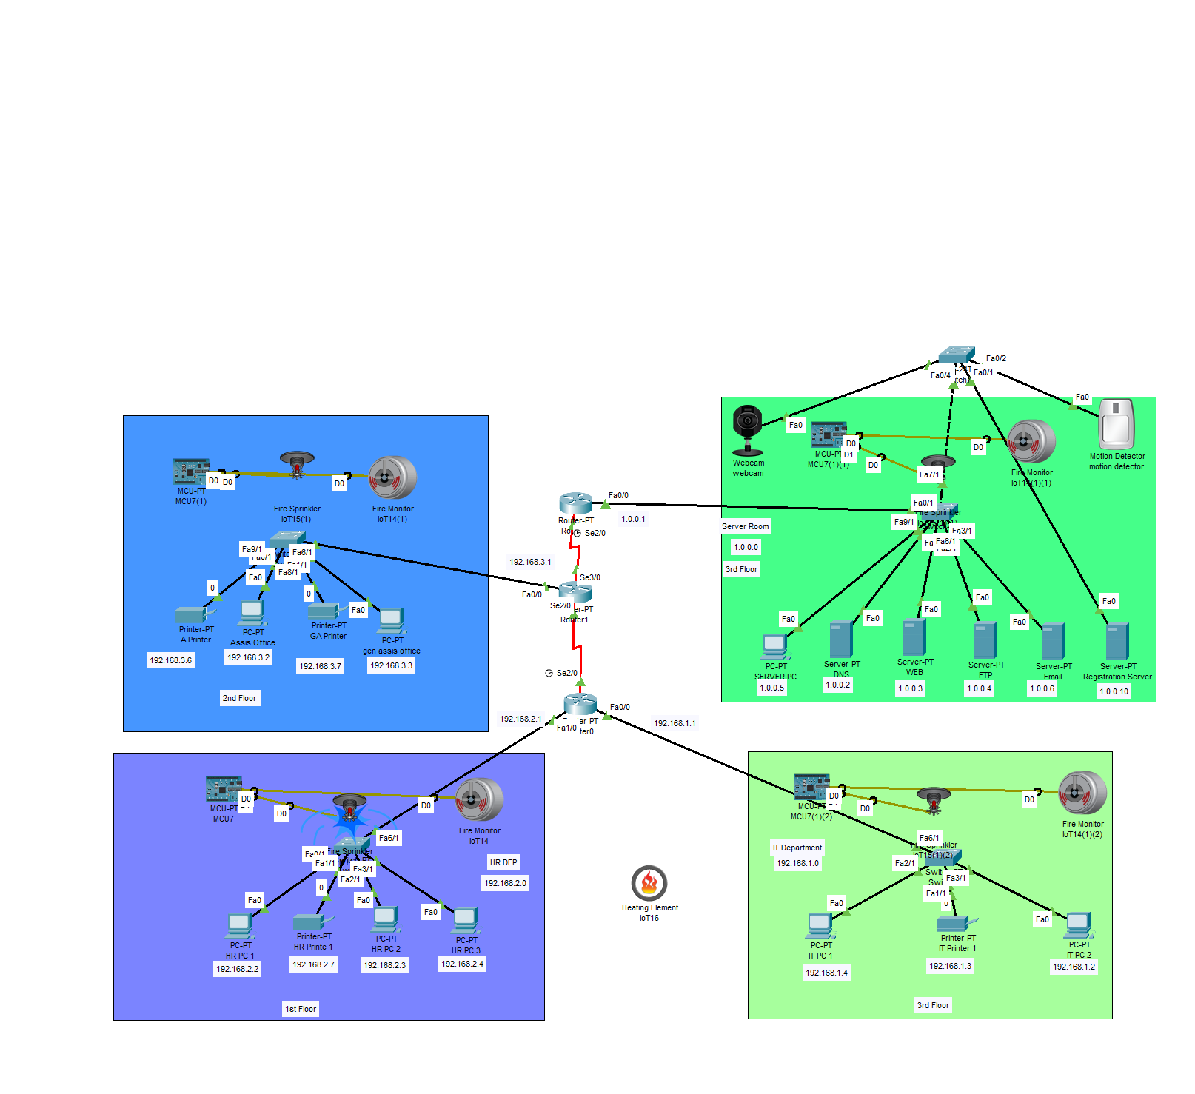

1. **IP- ADDRESS PLAN**

|  |  |
| --- | --- |
| **OFFICE ROOM (192.168.3.0)** | |
| **Assistant Officer** | **192.168.3.2** |
| **General Assistant Officer** | **192.168.3.3** |
| **Printer 1** | **192.168.3.6** |
| **Printer 2** | **192.168.3.7** |

|  |  |
| --- | --- |
| **Human resource Department (192.168.2.0)** | |
| **HR PC 1** | **192.168.2.2** |
| **HR PC 2** | **192.168.2.3** |
| **HR PC 3** | **192.168.2.4** |
| **HR Printer 1** | **192.168.2.7** |

|  |  |
| --- | --- |
| **IT Department (192.168.1.0)** | |
| **HR PC 1** | **192.168.1.4** |
| **HR PC 2** | **192.168.1.2** |
| **IT Printer 1** | **192.168.1.3** |

|  |  |
| --- | --- |
| **SERVER ROOM (1.0.0.0)** | |
| **SERVER PC** | **1.0.0.5** |
| **DNS SERVER** | **1.0.0.2** |
| **WEB SERVER** | **1.0.0.3** |
| **FTP SERVER** | **1.0.0.4** |
| **EMAIL SERVER** | **1.0.0.5** |
| **Registration Server** | **1.0.0.10** |

1. **Project Implementation Details**

Here we have 3 floors. 1st floor have HR department and 2nd floor have Office room in 3rd floor we have server room and IT department. Each and every edge device connect with a switch and all switch are connect with specific router. In server room we have 5 servers respectably DNS server WEB server FTP server EMAIL server and REGISTRATION server.

We add fire detector and motion detector to the IT department for strong security. Using all server every device can communicate with one another.

1. **Limitations**

There is a limitation for FTP server. Only server room and IT department can access all service like read, write, delete, rename, list etc.

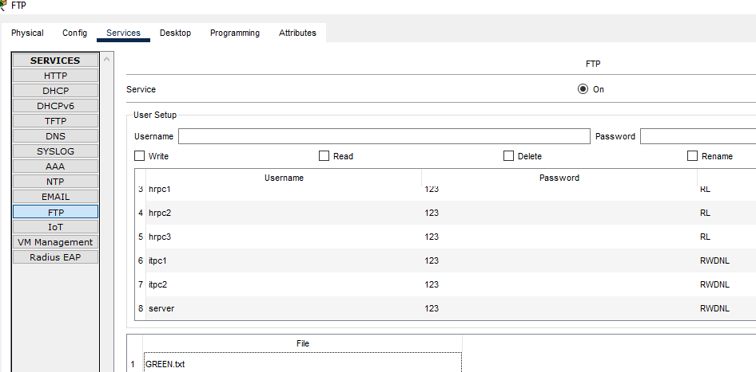

1. **Conclusion**

The outcome of the proposed system will be a fail-safe backbone network infrastructure which meets the requirements for readily available access to information and security of the private network, and also ensures optimized productivity when telecommunication services are accessed. The installed equipment allowed to organize high-speed wired and wireless Internet access throughout the whole complex of hospital buildings as well as providing transfer of all types of data throughout the single optimized network.

1. **Contribution of Individual Student:**

Md Ariful Hasan:- 2 ,5, 6, 7

Md Sha Imran:- 1, 3 ,4, 8, 9